Assignment 1
CSA05 Database Management Systems – CO1: Meridian Museum Loan Coordination (MySQL)

Queries

A. Create database and tables
- CREATE DATABASE IF NOT EXISTS museum_co1;
- USE museum_co1;
- CREATE TABLE lender (
id INT PRIMARY KEY,
name VARCHAR(100) NOT NULL
);
- CREATE TABLE artifact (
id INT PRIMARY KEY,
title VARCHAR(150) NOT NULL
);
- CREATE TABLE loan (
id INT PRIMARY KEY,
lender_id INT NOT NULL,
start_date DATE NOT NULL,
due_date DATE NOT NULL,
return_date DATE,
FOREIGN KEY (lender_id) REFERENCES lender(id),
CHECK (due_date >= start_date),
CHECK (return_date IS NULL OR return_date >= start_date)
);
- CREATE TABLE loan_object (
id INT PRIMARY KEY,
loan_id INT NOT NULL,
artifact_id INT NOT NULL,
FOREIGN KEY (loan_id) REFERENCES loan(id),
FOREIGN KEY (artifact_id) REFERENCES artifact(id),
UNIQUE (loan_id, artifact_id)
);
- CREATE TABLE condition_report (
id INT PRIMARY KEY,
loan_object_id INT NOT NULL,
report_type VARCHAR(20) NOT NULL,
report_date DATE NOT NULL,
notes VARCHAR(255),
FOREIGN KEY (loan_object_id) REFERENCES loan_object(id),
CHECK (report_type IN ('ARRIVAL','RETURN'))
);
- CREATE TABLE exhibition (
id INT PRIMARY KEY,
title VARCHAR(150) NOT NULL
);
- CREATE TABLE display_slot (
exhibition_id INT NOT NULL,
slot_no INT NOT NULL,
PRIMARY KEY (exhibition_id, slot_no),
FOREIGN KEY (exhibition_id) REFERENCES exhibition(id)
);
- CREATE TABLE placement (
loan_object_id INT NOT NULL,
exhibition_id INT NOT NULL,
slot_no INT NOT NULL,
placed_on DATE NOT NULL,
removed_on DATE,
PRIMARY KEY (loan_object_id, exhibition_id, slot_no),
FOREIGN KEY (loan_object_id) REFERENCES loan_object(id),
FOREIGN KEY (exhibition_id, slot_no) REFERENCES display_slot(exhibition_id, slot_no),
CHECK (removed_on IS NULL OR removed_on >= placed_on)
);
- SHOW TABLES;

B. Insert sample data
- INSERT INTO lender VALUES
(1,'National Heritage Trust'),
(2,'Royal Art Foundation'),
(3,'Private Collector'),
(4,'Historical Society');
- INSERT INTO artifact VALUES
(1,'Ancient Bronze Statue'),
(2,'Medieval Painting'),
(3,'Golden Coin'),
(4,'Stone Sculpture'),
(5,'Historic Manuscript'),
(6,'Ceramic Vase');
- INSERT INTO loan VALUES
(1,1,'2026-01-01','2026-06-01',NULL),
(2,2,'2026-02-01','2026-12-01',NULL),
(3,3,'2026-03-01','2026-05-01','2026-05-10'),
(4,1,'2026-04-01','2026-07-01',NULL);
- INSERT INTO loan_object VALUES
(1,1,1),(2,1,2),(3,2,3),(4,3,4),(5,4,5),(6,4,6);
- INSERT INTO condition_report VALUES
(1,1,'ARRIVAL','2026-01-01','Good condition'),
(2,2,'ARRIVAL','2026-01-01','Minor scratches'),
(3,3,'ARRIVAL','2026-02-01','Excellent condition'),
(4,4,'ARRIVAL','2026-03-01','Good condition'),
(5,4,'RETURN','2026-05-10','Returned safely');
- INSERT INTO exhibition VALUES
(1,'Ancient Civilizations'),
(2,'Historical Treasures');
- INSERT INTO display_slot VALUES (1,1),(1,2),(2,1),(2,2);
- INSERT INTO placement VALUES
(1,1,1,'2026-01-05',NULL),
(2,1,2,'2026-01-05',NULL),
(3,2,1,'2026-02-10',NULL),
(4,2,2,'2026-03-05','2026-04-01');

C. Row counts
- SELECT COUNT(*) AS Total_Lenders FROM lender;
- SELECT COUNT(*) AS Total_Artifacts FROM artifact;
- SELECT COUNT(*) AS Total_Loans FROM loan;
- SELECT COUNT(*) AS Total_Loan_Objects FROM loan_object;
- SELECT COUNT(*) AS Total_Reports FROM condition_report;

D. Use-case queries
- -- Query 1: Overdue loans still open
SELECT id, lender_id, due_date
FROM loan
WHERE return_date IS NULL
AND due_date < '2026-11-13';
- -- Query 2: Artifacts without condition evidence
SELECT a.id, a.title
FROM artifact a
JOIN loan_object lo ON lo.artifact_id = a.id
LEFT JOIN condition_report c ON c.loan_object_id = lo.id
WHERE c.id IS NULL;
- -- Query 3: Loan condition report details
SELECT l.id AS Loan_ID, a.title, c.report_type, c.report_date
FROM loan l
JOIN loan_object lo ON lo.loan_id = l.id
JOIN artifact a ON a.id = lo.artifact_id
LEFT JOIN condition_report c ON c.loan_object_id = lo.id;
- -- Query 4: Exhibition placement details
SELECT e.title AS Exhibition, s.slot_no, a.title AS Artifact
FROM placement p
JOIN display_slot s ON s.exhibition_id = p.exhibition_id
AND s.slot_no = p.slot_no
JOIN exhibition e ON e.id = s.exhibition_id
JOIN loan_object lo ON lo.id = p.loan_object_id
JOIN artifact a ON a.id = lo.artifact_id;
- -- Query 5: Loans containing multiple artifacts
SELECT loan_id, COUNT(*) AS Artifact_Count
FROM loan_object
GROUP BY loan_id
HAVING COUNT(*) > 1;
- -- Query 6: Lender loan history
SELECT le.name, l.id AS Loan_ID, l.start_date, l.due_date, l.return_date
FROM lender le
JOIN loan l ON l.lender_id = le.id
WHERE le.id = 1;
- -- Query 7: Return condition reports
SELECT c.id, lo.artifact_id, c.report_date, c.notes
FROM condition_report c
JOIN loan_object lo ON lo.id = c.loan_object_id
WHERE c.report_type = 'RETURN';
- -- Query 8: Artifacts displayed beyond loan expiry
SELECT a.title, l.due_date, p.placed_on, p.removed_on
FROM placement p
JOIN loan_object lo ON lo.id = p.loan_object_id
JOIN artifact a ON a.id = lo.artifact_id
JOIN loan l ON l.id = lo.loan_id
WHERE p.removed_on IS NULL
AND l.due_date < '2026-11-13';

E. Invalid data tests (constraints)
- -- Invalid primary key: duplicate lender
INSERT INTO lender VALUES (1,'Duplicate Lender');
- -- Invalid foreign key: lender does not exist
INSERT INTO loan VALUES (99,999,'2026-01-01','2026-05-01',NULL);
- -- Invalid date: due date before start date
INSERT INTO loan VALUES (98,1,'2026-06-01','2026-01-01',NULL);
- -- Invalid report type
INSERT INTO condition_report VALUES (99,1,'UNKNOWN','2026-05-01','Invalid category');

Outputs

A. Create database and tables (including SHOW TABLES)
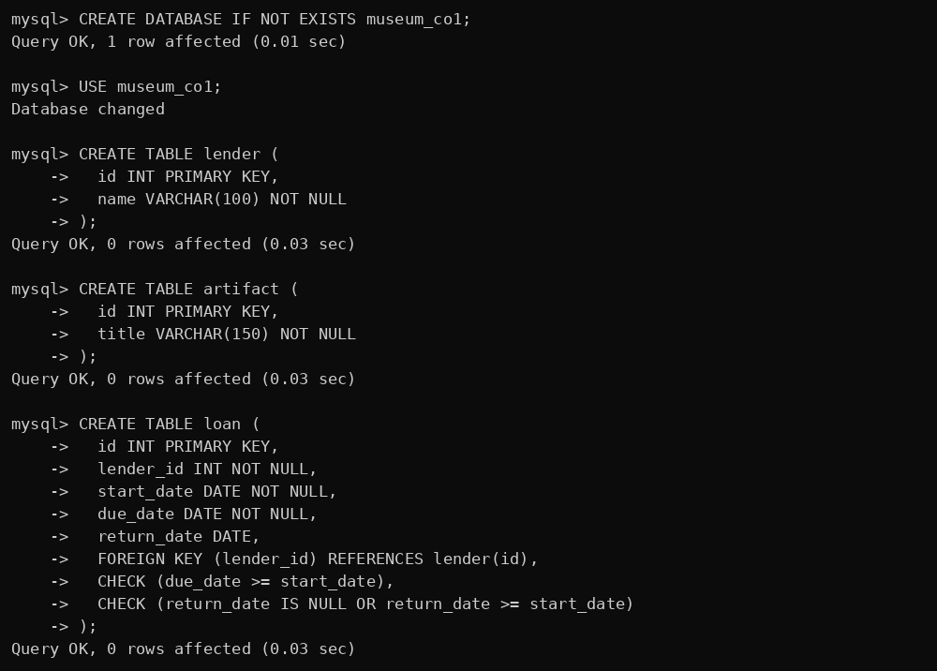
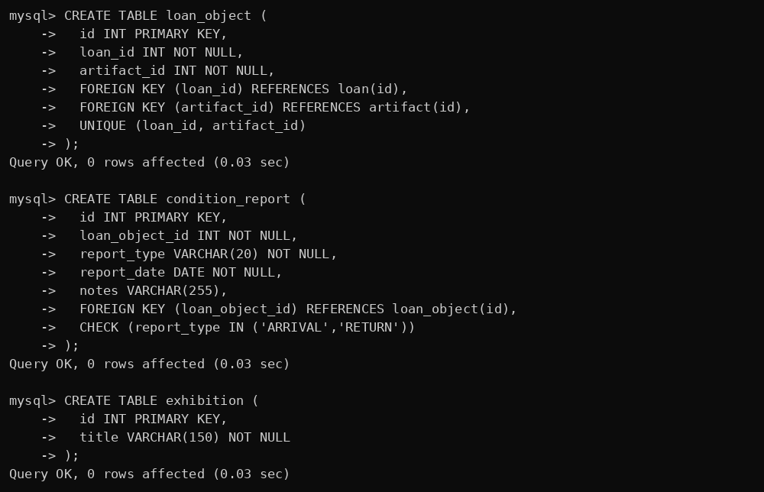
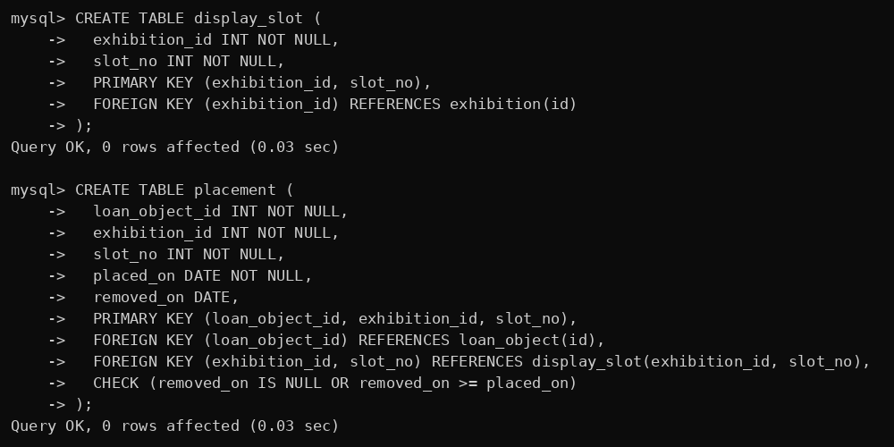
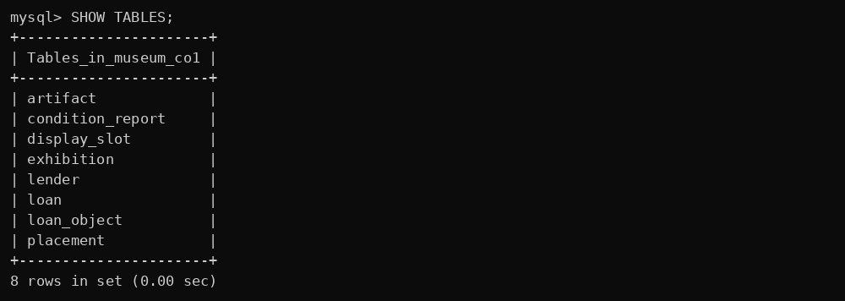

B. Insert sample data
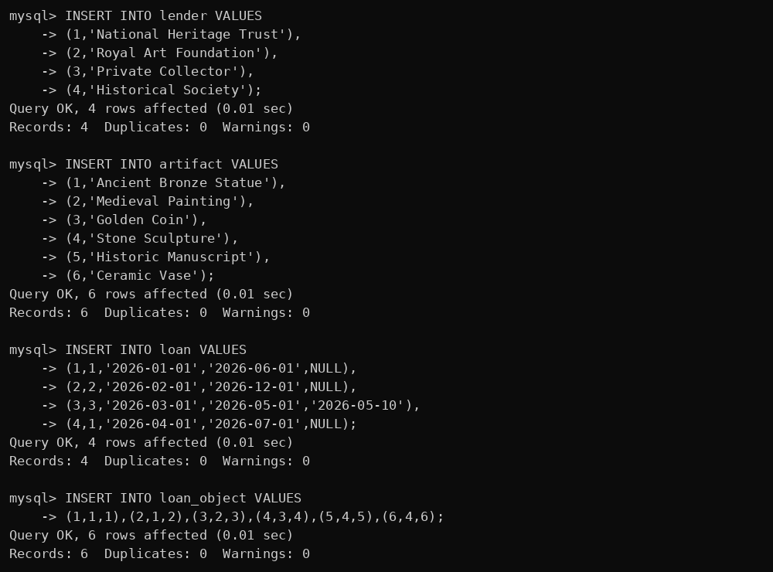
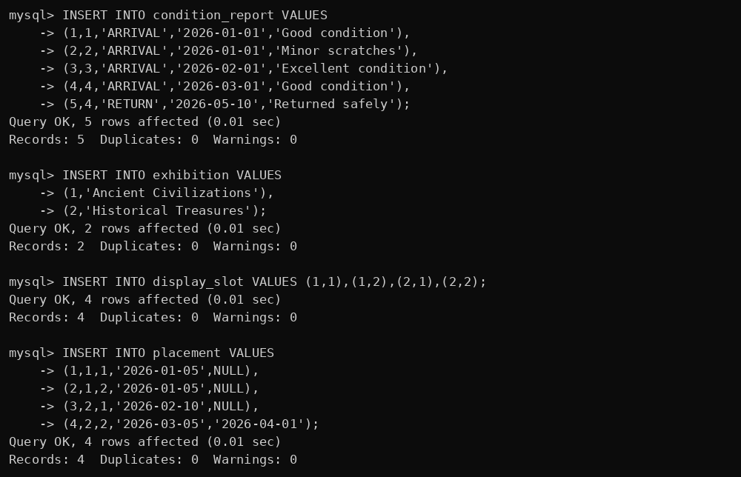

C. Row counts
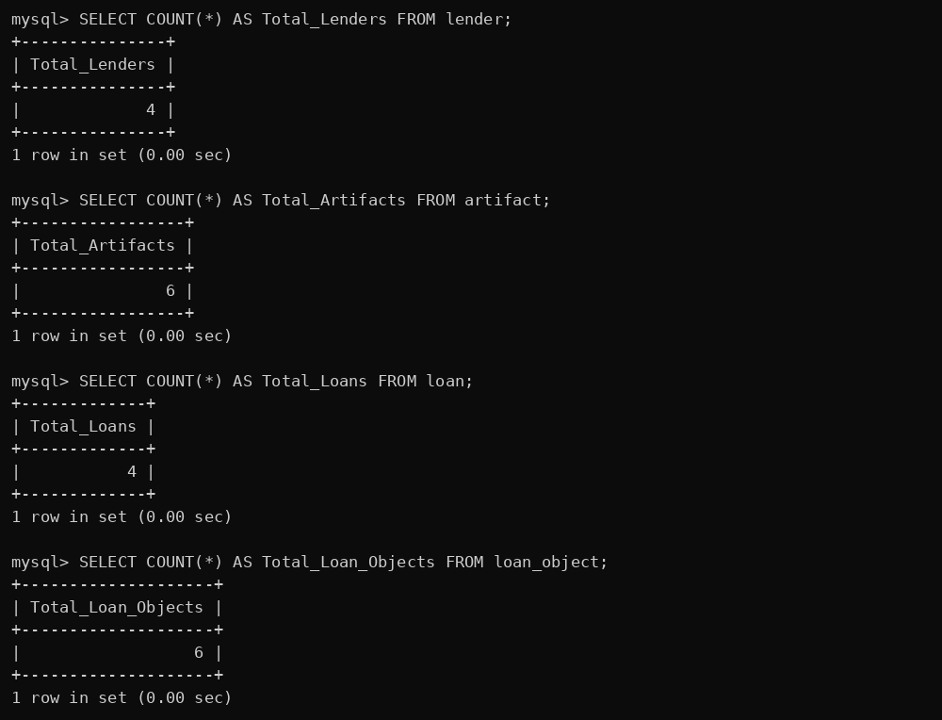
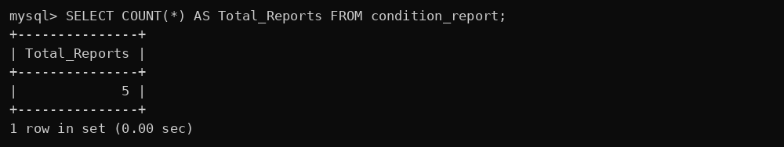

D. Use-case queries 1–4
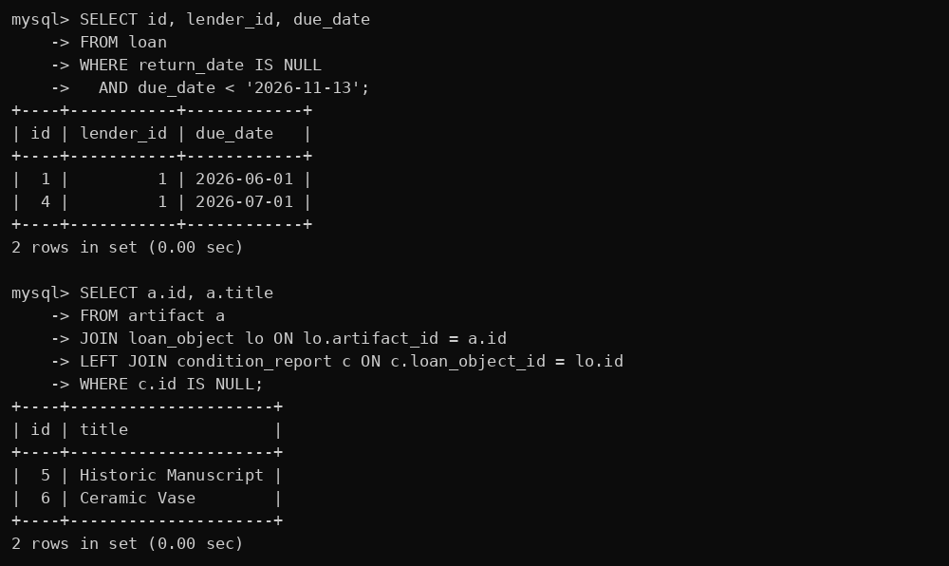
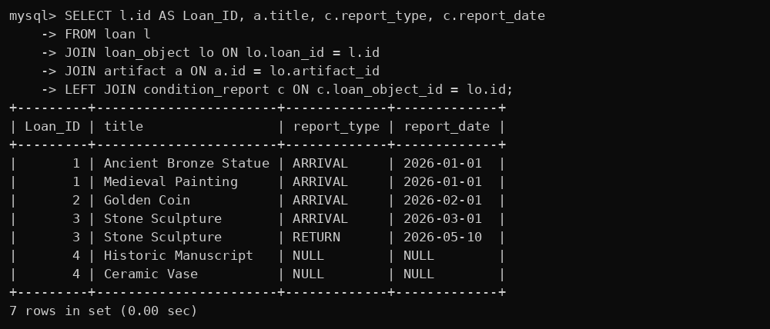
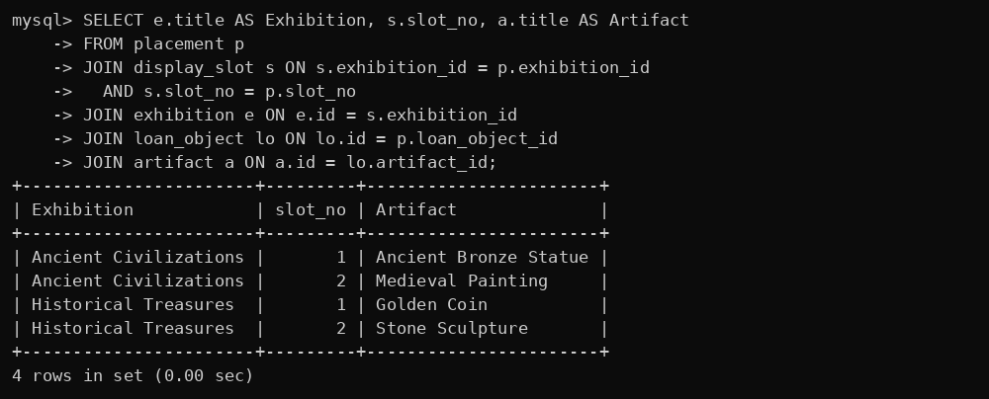

D. Use-case queries 5–8
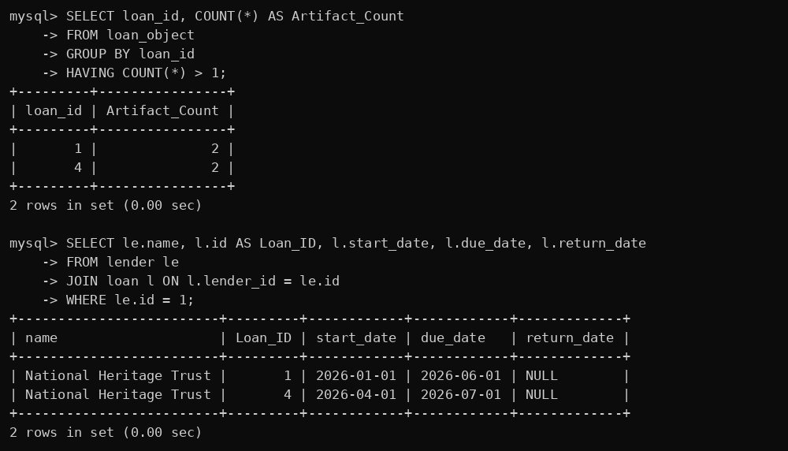
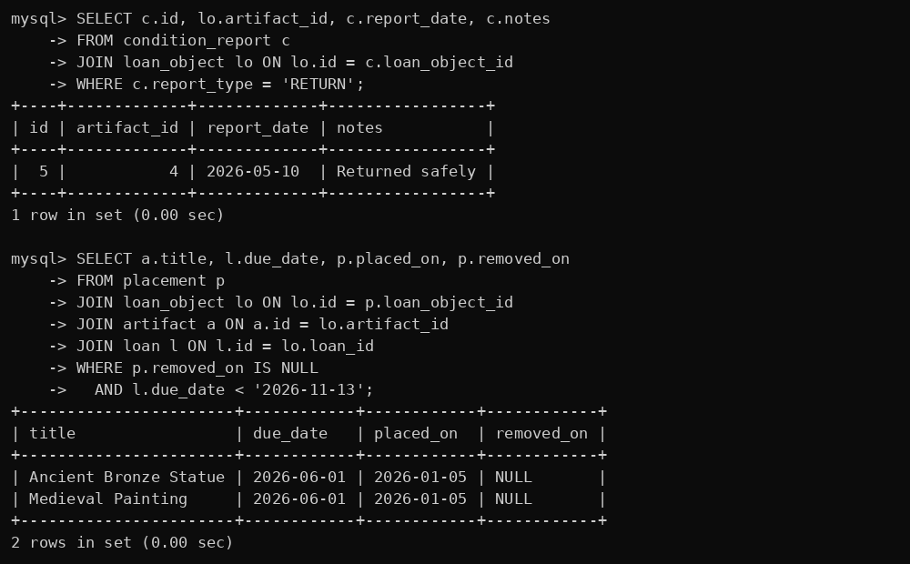

E. Invalid data tests – error messages


